**SUMMARY REPORT OF THE PERFORMED INSPECTION ON WEATHER STATIONS LOCATED IN NORTHERN PROVINCE.**

1. **INTRODUCTION**

These reports present the findings from the inspection of the Manual Rain Gauge, Climatology Station, Automatic Rain Gauge, and Automatic Weather Station carried out in Rulindo, Gicumbi, Gakenke, Musanze and Burera districts from November 9th to 14th, 2025. A total of 55 stations are inspected including 3 Agrometeorogical stations, 11 Climatology stations,14 Rainfall station,19 Automatic weather stations and 8 Automatic rain gauges.

The objectives were to inspect instrument placement and station conditions, verify the accuracy of collected weather data, assess observers’ competence, and ensure local authorities are informed about the role and operations of meteorological stations.

During the inspection, stations were visited to evaluate their siting and overall suitability. Where required, corrective measures were implemented, and recommendations for further action were issued. Data forms were collected from manual stations, technical issues affecting station performance were identified, and preventive maintenance was carried out on the automatic weather stations.

1. **TEAMS**

|  |  |  |
| --- | --- | --- |
|  | **MEMBERS** | **INSPECTED DISRICTS** |
| **Team 1** | * UWIZERA Chantal * NIWAMANYA Angel * NSHIMIYIMANA Nadjibu | * RULINDO (WEST PART) * GAKENKE * MUSANZE |
| **Team 2** | * INGABIRE Diane * BIKORIMANA Christian * MUREBWAYIRE UYIZERA Macrine | * RULINDO (EAST PART) * GIBUMBI * BURERA |

1. **FINDINGS**
   1. S**TATIONS WITH COMPROMISED FENCES AND BASE FOUNDATIONS**

|  |  |  |  |
| --- | --- | --- | --- |
| **#** | **SITE NAME** | **DISTRICT** | **DESCRIPTION OF ISSUES** |
| 1. **COMPROMISED FENCES** | | | |
| 1 | KAGOGO | BURERA | High-tensile fencing wires are completely missing. |
| 2 | RWERERE | BURERA | The bases of the fence tubes were partially fractured. |
| 3 | CYERU | BURERA | Fence’s wires with approximates 2m2 were deteriorated. |
| 4 | NTARUKA | BURERA | Two tubes near the fence gate are broken at the base. |
| 5 | MUGAMBAZI | RULINDO | Fencing wires near the gate and at the rear of the fence are distorted, with the affected area of the fence approximately 3 m². |
| 6 | RUSHASHI | GAKENKE | Fence’s wires with approximates 4m² were deteriorated. |
| 7 | JANJA | GAKENKE | All Fence’s wires were deteriorated. |
| 8 | BUSOGO | MUSANZE | Fence’s wires with approximates 4m² were deteriorated. |
| 1. **RUSTED / OLD PAINTED FENCES** | | | |
| 1 | CYINZUZI | RULINDO | Corroded fence wires and tubes |
| 2 | RUHUNDE | BURERA | Corroded fence wires and tubes |
| 3 | RUSHASHI | GAKENKE | Old painted of fence wires and tubes |
| 4 | JANJA | GAKENKE | Old painted of fence wires and tubes |
| 5 | BUSOGO | MUSANZE | Old painted of fence wires and tubes |
| 6 | REMERA | MUSANZE | Old painted of fence wires and tubes |
| 7 | GICUMBI | GICUMMBI | Old painted of fence wires and tubes |
| 1. **STRUCTURAL DEGRADATION OF THE BASE FOUNDATION** | | | |
| 1 | MUGAMBAZI | RULINDO | The foundation base exhibits signs of structural weakening and has begun to deteriorate. |
| 2 | RWERERE | BURERA | Foundation is completely damaged |
| 3 | CYERU | BURERA | The foundation base exhibits signs of structural weakening and has begun to deteriorate. |
| 4 | RULI | GAKENKE | The foundation has begun to deteriorate. |
| 5 | JANJA | GAKENKE | Foundation is damaged |
| 6 | GICUMBI | GICUMBI | Foundation at the entrance gate is damaged. |

* 1. **METEOROLOGICAL STATIONS WITH UNSUITABLE SITING**

|  |  |  |  |  |
| --- | --- | --- | --- | --- |
| **#** | **STATION** | **DISTRICT** | **DESCRIPTION OF ISSUES** | **RECCOMENDATION** |
| 1 | RUTONGO MRG | RULINDO | Exposed between obstacles(long plantation). | Relocate the station to an open area. |
| 2 | CYINZUZI ARG | RULINDO | It is located near a tree. | Relocate the station to same fence of CYINZUZI Climatology station. |

* 1. **MANUAL STATIONS REQUIRING NEW INSTRUMENTS/EQUIPMENTS**

|  |  |  |  |  |
| --- | --- | --- | --- | --- |
| **#** | **STATION NAME** | **DISTRICT** | **DESCRIPTION OF ISSUES** | **RECCOMENDATION** |
| 1 | RUTONGO | RULINDO | There is old versioned of water collector whose 8 mmmeasuring cylinder. | Replace the existing collector with a new 10 mm measuring cylinder model. |
| 2 | MULINDI | GICUMBI | Too old versioned of thermo-hygrometer. | Replace the rain gauge support/soldering the hook support on the rain gauge support. |
| 3 | GICUMBI | GICUMBI | No soil thermometer at 10 Cm and 20 Cm and evaporation pan. | The following instruments need to be installed soil thermometers at depth of 10 Cm and 20 Cm and installing the evaporation pan. |
| 4 | BUTARO | BURERA | The hook support used to hold the rain collector is re-attached from rain gauge support. | Replace the rain gauge support/soldering the hook support on the rain gauge support. |
| 5 | NEMBA | GAKENKE | Measuring cylinder was broken on its stand. | Providing new measuring cylinder. |
| 6 | NTARUKA | BURERA | The padlock is no longer operates due to rusting. | providing water proof padlock. |
| 7 | CYANIKA | BURERA | The key of padlock at the fence is not available. | Providing new water proof padlock. |
| 8 | BUSOGO | MUSANZE | Minimum grass thermometer is exposed. | Metal shield cover to protect thermometer. |

* 1. **TECHINICAL ISSUES ON AUTOMATIC WEATHER STATIONS**

|  |  |  |  |  |
| --- | --- | --- | --- | --- |
| **#** | **STATION** | **DISTRICT** | **FINDINGS** | **RECOMMENDATIONS** |
| 1 | CYANIKA AWS | BURERA | During the visit the data logger was off which implies the malfunctioning of the battery. | To replace the battery |
| 2 | KINONI ARG | BURERA | Water collector was blocked the water do not pass from the water filter. | To replace water collector. |
| 3 | RWERERE ARG | BURERA | The water filter was blocked, preventing water from passing through. | Replace water collector. |
| 4 | CYUMBA ARG | GICUMBI | The station had no battery. During inspection, a battery was supplied; however, it was not new and failed to operate. | Replace the battery with a new, fully functional one. |
| 5 | BYUMBA AWS | GICUMBI | Station does not report/troubleshooting was made but resist. | Further investigation of data logger communication protocol. |
| 6 | CYABINGO ARG | GAKENKE | The water filter was blocked, preventing water from passing through. | Replace water collector |
| 7 | SHINGIRO ARG | MUSANZE | The water filter was blocked, preventing water from passing through. | Replace water collector |
| 8 | NYANGE ARG | MUSANZE | The water filter was blocked, preventing water from passing through. | Replace water collector |

1. **OTHER OBSERVATIONS**
2. Instruments at CYERU AWS, BUNGWE AWS, CYANIKA AWS were very dirt; therefore, the regular preventive maintenance is required.
3. The Stevenson screens at all sites have old paint and need repainting.
4. The security officer at the NTARUKA site emphasized the need for a shelter room.
5. Fencing is needed at the Muyongwe and Rukozo sites to ensure complete instrument security.
6. **STATIONS WITH NO ISSUES**
7. Rusiga MRG, Rusiga ARG, Minazi MRG, Minazi ARG, Nyirangarama AWS, Shingiro MRG, Cyabingo MRG, Remera-Nyange MRG, Nyamiyaga MRG, Kinoni MRG and Rwesero MRG, Bwisige ARG and Bungwe AWS.
8. At Rusasa and Cyanika AWS, the surroundings had overgrown trees and grasses, and Rusasa also had a small security hut inside the fence. These issues were resolved by clearing and cleaning the sites.
9. **RECOMMENDATIONS**
10. **The mentioned stations with deteriorating fences require urgent rehabilitation to guarantee the security of the instruments.**
11. Stations showing weakening in the concrete base foundation require prompt action to prevent further damage, and those with already damaged foundations need urgent rehabilitation to protect the fence.
12. The corrective maintenance of the mentioned automatic weather stations to ensure their fully operational.
13. Stations should undergo regular inspections and preventive maintenance to avoid significant issues.
14. **ANNEX**

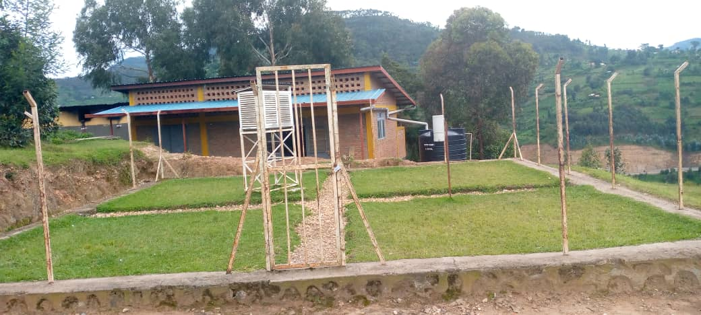 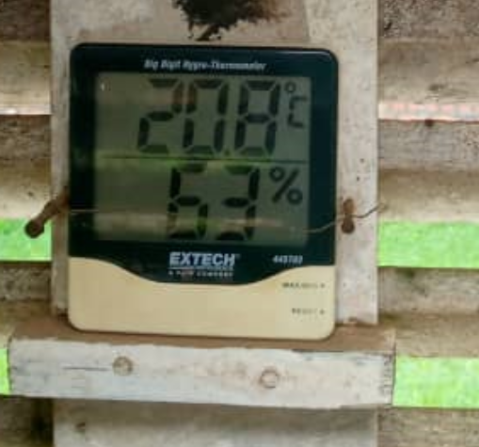Fi**gure 1:KAGOGO Climatology station Figure 2:MULINDI Climatology station**

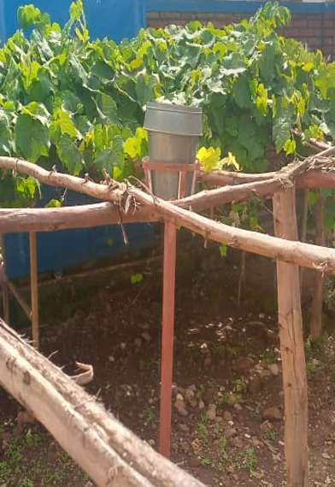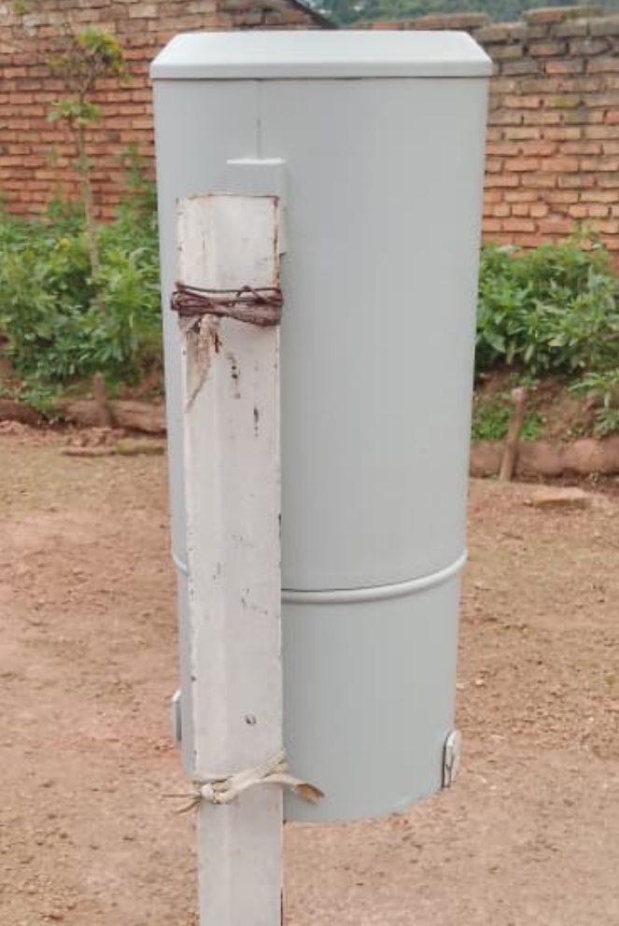

**Figure 3: RUTONGO Manual Rain gauge Figure 4: BUTARO Manual Rain gauge**

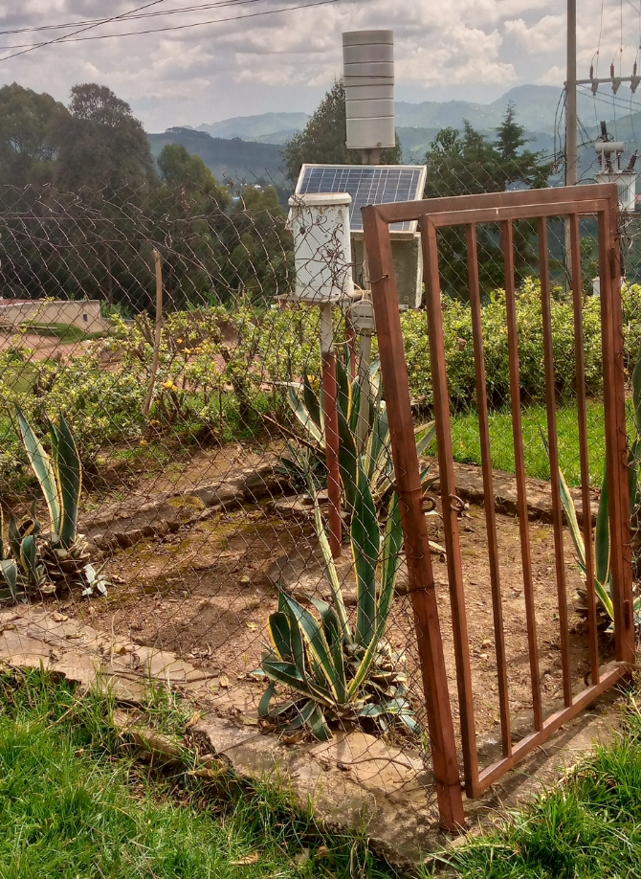 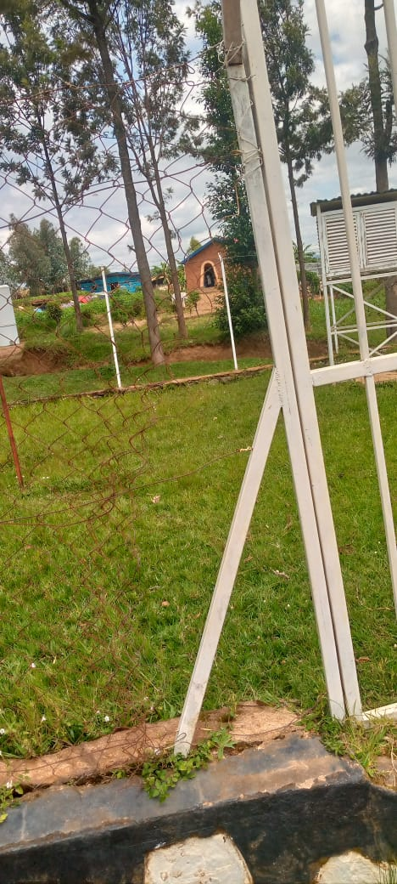

**Figure 5: RWERERE ARGFigure 6: MUGAMBAZI Site**

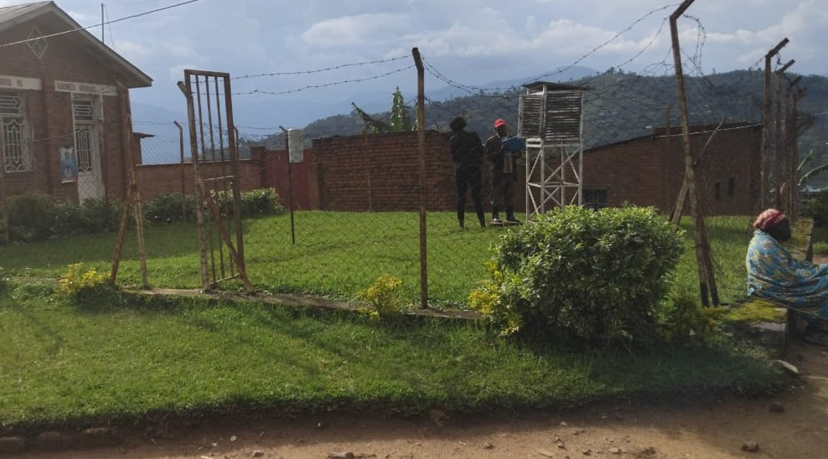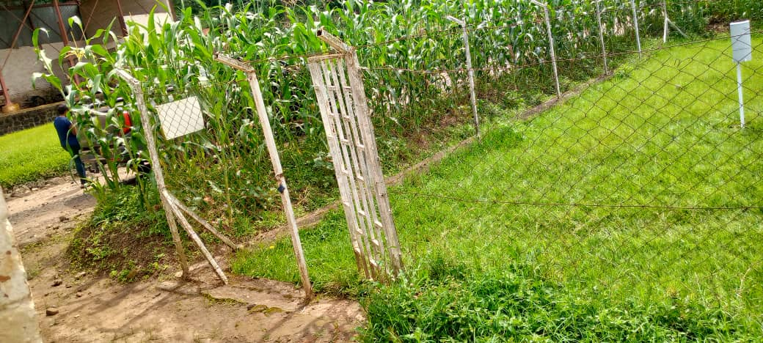

**Figure 7: NTARUKA Site Figure 8: JANJA Site**

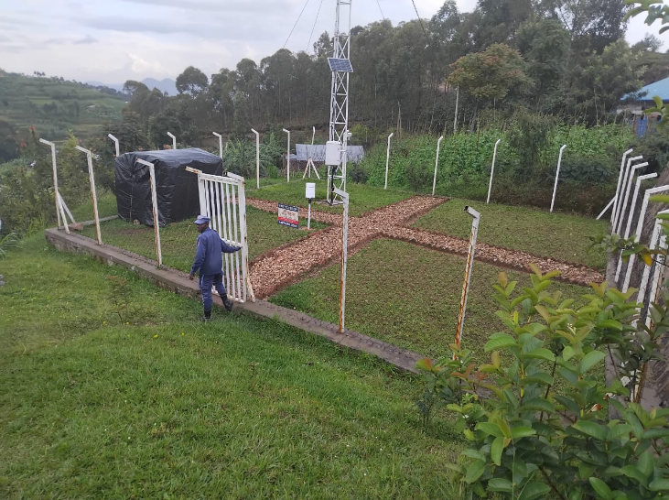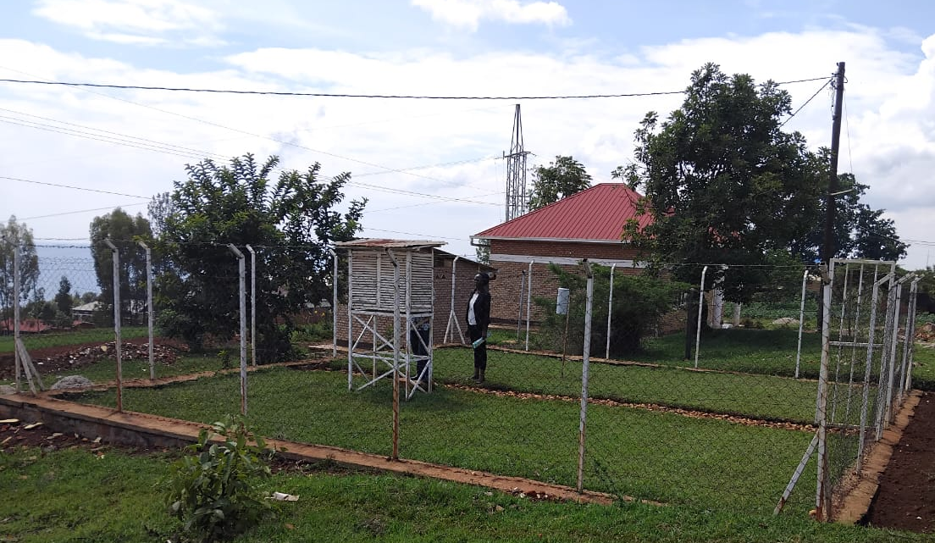**Figure 9: RULI Site Figure 10: RUSASA AWS Site**

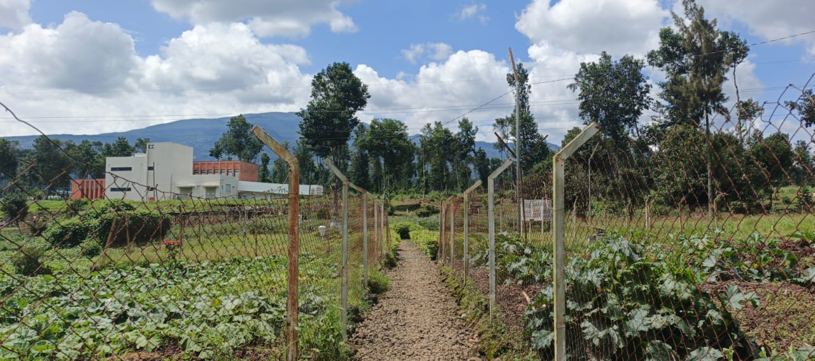 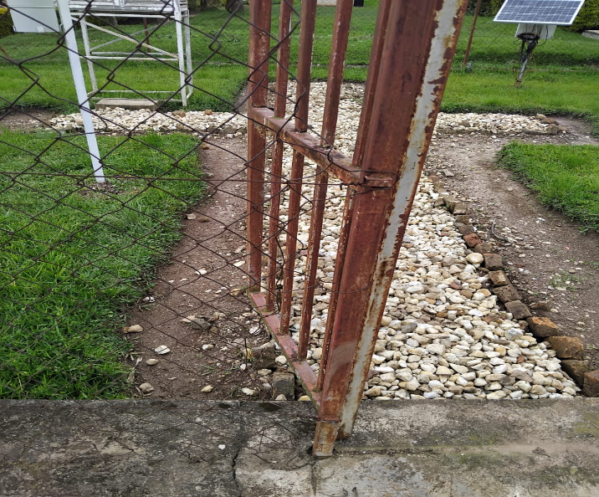

**Figure 11: RUSHASHI Site Figure 12: BUSOGO Site**

**Prepared by:**

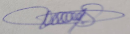

UWIZERA Chantal NIWAMANYA Angel NSHIMIYIMANA Nadjibu

Observation Supervisor Observation Officer Observation Supervisor

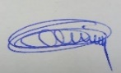 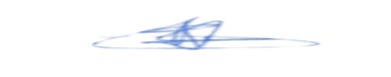 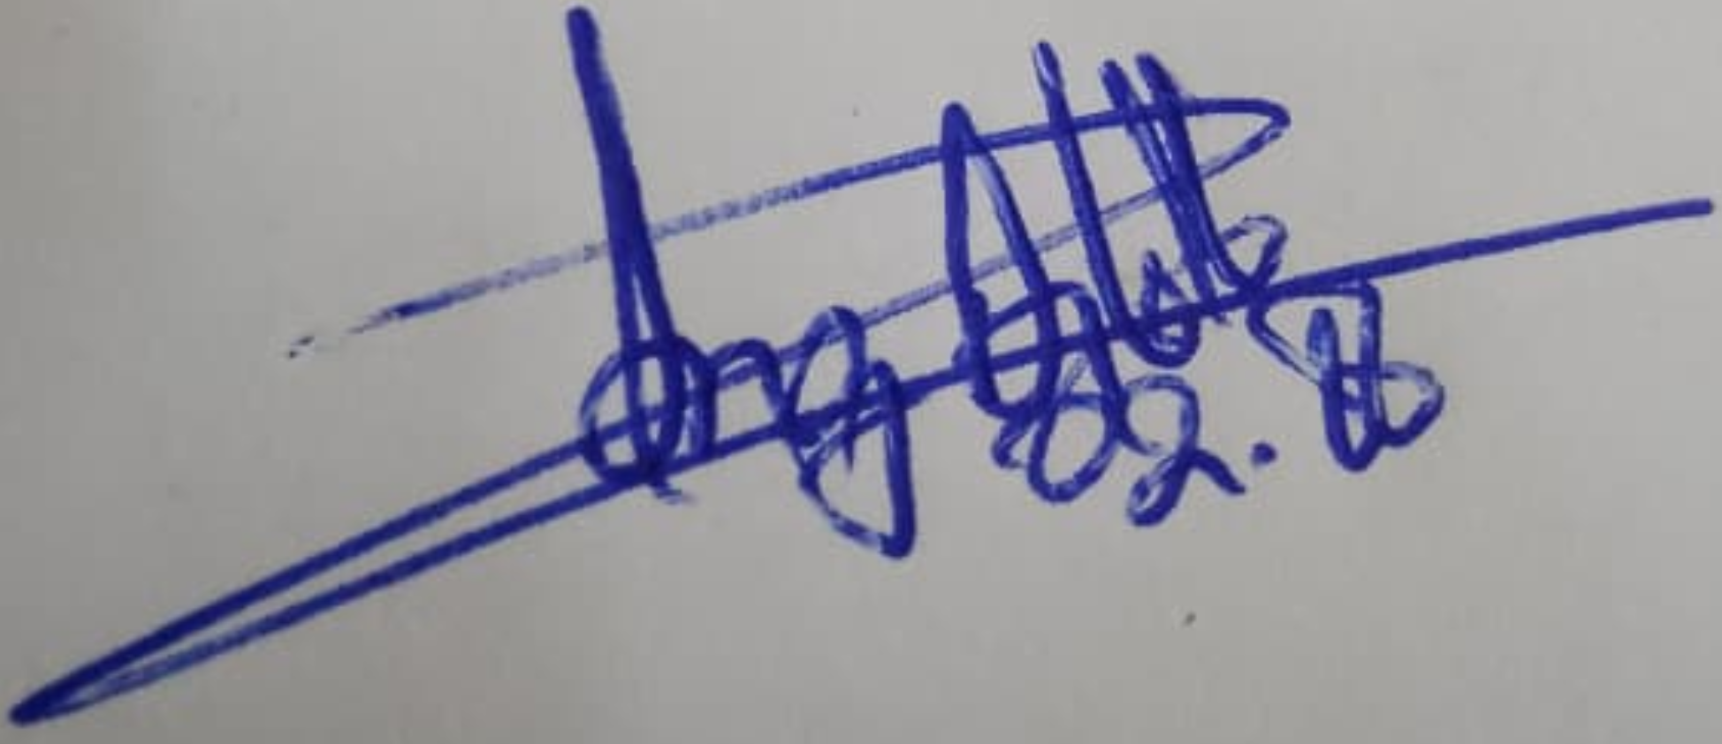

BIKORIMANA Christian MUREBWAYIRE UYIZERA Macrine INGABIRE Diane

Ag.Data Quality Control Officer Observation Officer Observation Officer

**Approved:**

Dr IYAKAREMYE Vedaste

Division Manager of DOQC&P Division